
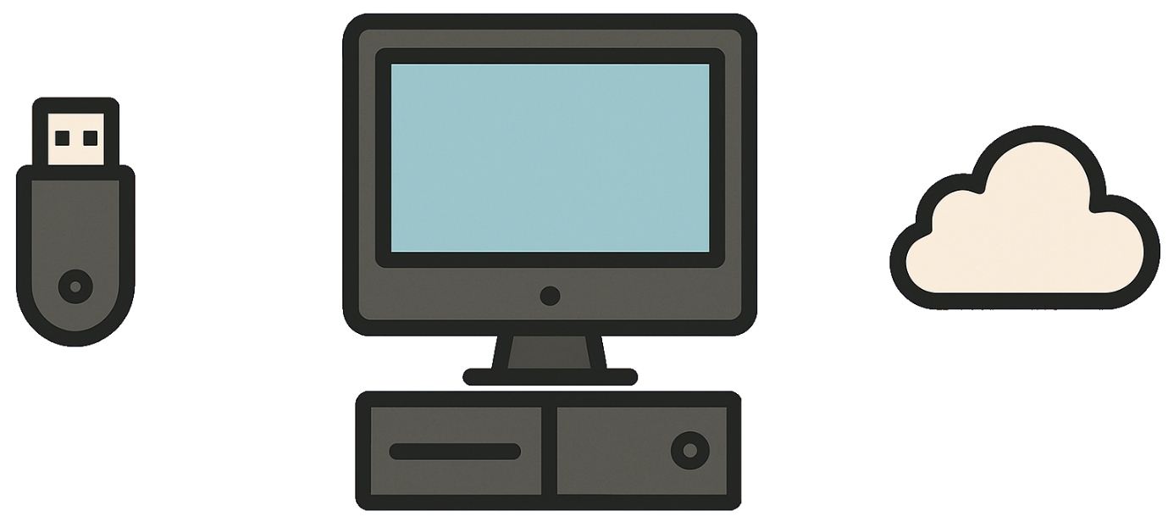

Backing Storage

Computing Science - Basics
- Targets
- I can state examples of storage devices
- I can state three categories of backing storage
- I can describe the advantages / disadvantages of backing storage categories
- I can explain why computers require backing storage
- I can identify where a file should be saved
Name:
Class:
Teacher:
Mark: | /35

Task 1
1. | What is backing storage used for? |  | (1 mark)
 | A. | To make the computer run faster
 | B. | To save data permanently
 | C. | To connect to the internet
 | D. | To show images on the screen

2. | Why do computers require backing storage? |  | (1 mark)
 | A. | To stop the computer from overheating
 | B. | To keep the internet connection active
 | C. | To help software install faster
 | D. | To keep data even when the power is turned off

3. | Which of the following is not a type of backing storage? |  | (1 mark)
 | A. | External
 | B. | Internal
 | C. | Processor
 | D. | Cloud

4. | Which is an example of cloud storage? |  | (1 mark)
 | A. | USB Flash Drive
 | B. | Hard Drive (HDD)
 | C. | Google Drive
 | D. | Memory Card



Task 2
Draw a line to match each term with its definition. | (4 marks)

Term |  | Description
Backing storage |  | Storage outside the computer
Internal storage |  | A device used to save data
External storage |  | Storage inside the computer
Cloud storage |  | Storage on the internet

Task 3
cloud | internal | internal
external | external | permanently
cloud | storage | internet

Fill in the blanks using the table above.
A. | Backing __________ is used to save data __________so it is not lost when the computer is turned off. | (3 marks)
B. | Data can be saved using __________, __________, or __________storage. | (3 marks)
C. | __________storage needs an __________connection to work properly. | (1 mark)
B. | __________storage is built into the computer. | (1 mark)
B. | __________storage must be connected to the computer to be used. | (1 mark)

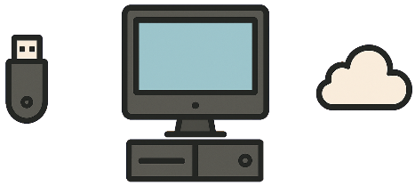

Task 4

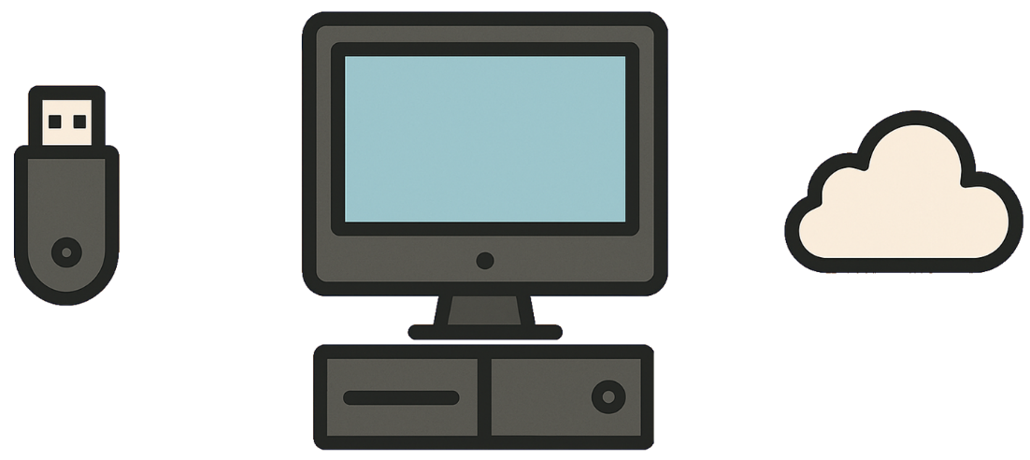

A. | Explain why computers require backing storage. | (1 mark)

B. | State the three categories of backing storage. | (3 marks)

C. | Name these cloud storage services. |  | (4 marks)
 | 
 | 
 | 
 | 

Task 5 – Complete the table
 | Internal  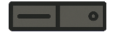 | External  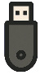 | Cloud  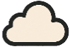
State two example storage devices. | (2 marks) | (2 marks)
Describe an advantage. | (1 mark) | (1 mark) | (1 mark)
Describe a disadvantage. | (1 mark) | (1 mark) | (1 mark)

Check your understanding

Mark your answers
Mark your answers using the study kit at www.superstudyparty.com  Computing Science ➔ S1-S3 ➔ Computing Science – Basics ➔ Backing storage |  |  | 
Mark: | /35

2. Tick your targets
- Tick the targets you have achieved  - Give evidence of each achieved target - “Task 1a” |  | 
- Targets | Evidence
- I can state examples of storage devices
- I can state three categories of backing storage
- I can describe the advantages / disadvantages of backing storage categories
- I can explain why computers require backing storage
- I can identify where a file should be saved

Study
Continue your study at www.superstudyparty.com  Computing Science ➔ S1-S3 ➔ Computing Science – Basics ➔ Backing storage |  | 
Target(s) I will study | Study Method
- Super Study Party
- Study Cards
- Mind Map
- Write notes
- Other

