
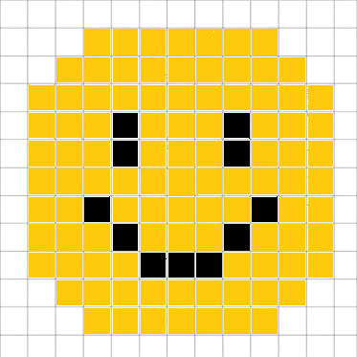

Bitmap Graphics
Computing Science - Basics
- Targets
- I can define the term bitmap graphic
- I can define the term pixel
- I can define the term resolution
- I can explain how resolution affects image quality
- I can identify the resolution of a bitmap graphic
- I can create a bitmap graphic
Name:
Class:
Teacher:
Mark: | /22

Task 1
1. | What is bitmap graphic? |  | (1 mark)
 | A. | A square on a bitmap grid
 | B. | A grid of pixels
 | C. | An image from the printer
 | D. | The number of pixels in an image

2. | What is a pixel? |  | (1 mark)
 | A. | A square on a bitmap grid
 | B. | A grid of pixels
 | C. | An image from the printer
 | D. | The number of pixels in an image

3. | What does resolution mean when describing a bitmap image? |  | (1 mark)
 | A. | A square on a bitmap grid
 | B. | A grid of pixels
 | C. | An image from the printer
 | D. | The number of pixels in an image

4. | How will a high resolution affect the quality of a bitmap? |  | (1 mark)
 | A. | The graphic will have limited details
 | B. | It will reduce the number of pixels
 | C. | It will give the image more colours
 | D. | The graphic will be able to show more detail



Task 2
Draw a line to match each term with its definition. | (3 marks)

Term |  | Description
Bitmap graphic |  | The number of pixels in an image
Pixel |  | Grid of pixels
Resolution |  | A square on a bitmap grid

Task 3
bitmap | detail | grid
pixel | pixels | pixels
lower | higher | resolution

Fill in the blanks using the table above.
A. | A __________ is one square in a bitmap graphic. | (1 mark)
B. | __________describes the number of __________in an image. | (2 marks)
C. | A __________graphic is created using a __________of __________. | (3 marks)
D. | A __________resolution allows for more __________compared to a  __________resolution. | (3 marks)

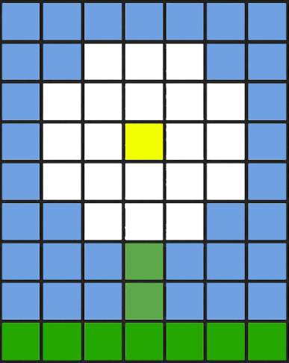

Task 4
- Identify the resolution of this bitmap graphic. | (2 marks)
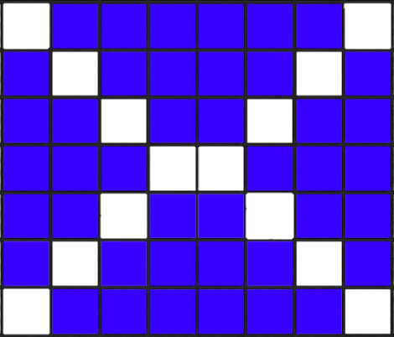

- Identify the resolution of this bitmap graphic. | (2 marks)
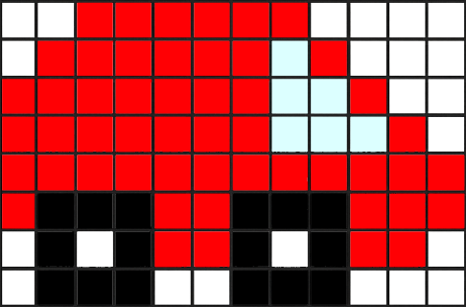

- Identify the resolution of this bitmap graphic. | (2 marks)
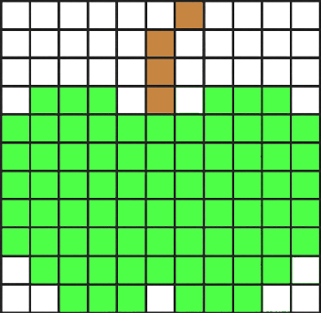

Task 5
Create the following bitmaps using https://www.piskelapp.com/ and insert the pictures into the boxes.
- Create a bitmap of a smiley face.

- Create a bitmap of a house.

- Create a bitmap of a dog.

- Create a bitmap of a famous logo.

Check your understanding

Mark your answers
Mark your answers using the study kit at www.superstudyparty.com  Computing Science ➔ S1-S3 ➔ Computing Science – Basics ➔ Bitmap Graphics |  |  | 
Mark: | /22

2. Tick your targets
- Tick the targets you have achieved  - Give evidence of each achieved target - “Task 1a” |  | 
- Targets | Evidence
- I can define the term bitmap graphic
- I can define the term pixel
- I can define the term resolution
- I can explain how resolution affects image quality
- I can identify the resolution of a bitmap graphic
- I can create a bitmap graphic

Study
Continue your study at www.superstudyparty.com  Computing Science ➔ S1-S3 ➔ Computing Science – Basics ➔ Bitmap Graphics |  | 
Target(s) I will study | Study Method
- Super Study Party
- Study Cards
- Mind Map
- Write notes
- Other

