NPA Computing Technologies Project (Level 4)

EXAMPLE ANSWERS

Name
Write your name and level (4/5/6) below.
Name | Level
Lucy Smith | 4

Team members
Write the names of your team members and their levels below.
Name | Level
Sophie Kenny | 4
Chris Hamilton | 5
Tom Muir | 6


Project– Heavenly Bakes
Your team must design and build a multi-page website for the cake shop, Heavenly Bakes.
The pages must be linked together to form one complete website.
Example Pages | Description
Home.html | Welcome with a short paragraph about the bakery and a few cake images
About.html | Information about the history of Heavenly Bakes, including the story of how it started
Menu.html | A list of available cakes with short descriptions, prices, and serving sizes
Custom.html | Information on custom cake orders, like wedding cakes or themed birthday cakes, with example pictures
Bakers.html | Introduction to the bakery team with photos and short bios of each baker
Special.html | Spotlight on one special cake each month with a description and a promotional offer
Contact.html | A page with the bakery’s address, phone number, email address, a contact form (optional), and a small map image
… | …

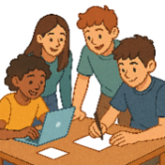
Assessment criteria
The practical requirements for each level are listed below. You must also demonstrate teamwork and your contribution to the project.
Level | Requirements | HTML | CSS
4 | One HTML page | Heading  Paragraph  Image  Link | None
5 | Two HTML pages  Internal CSS | Heading  Paragraph  Image  Link  List | Font  Font colour  Font size  Text alignment  Background colour
6 | Three HTML pages  External CSS | Heading  Paragraph  Image  Link  List  Form  Div | Font  Font colour  Font size  Text alignment  Background colour

Project plan

Task 1 - Roles and responsibilities
Each member of the team needs to pick a role and choose different pages of the website to develop.
Identify each members role and the pages they will develop.
Name: | Lucy | Sophie | Tom | Chris
Role: | Lead Research | Lead Design | Lead Coder | Lead Tester
Pages:  (Responsibilities) | About.html | Special.html | Home.html  Contact.html  Menu.html | Custom.html  Bakers.html

Task 2 - Tasks and timescales
Your team must work together to create a project plan. List the main tasks that need to be completed for the project.
Milestone | Task | Person | Start Date | End Date
Plan | Create text for the website | Team
Plan | Find / create copyright free images | Team

Design | Identify hardware requirements | Team
Design | Identify software requirements | Team
Design | Identify any potential security concerns | Team
Design | Pick design theme and colours | Sophie
Design | Team wireframes | Team
Design | About page wireframe | Lucy
Design | Develop a test plan | Team

Implementation | Team HTML code | Team
Implementation | About page HTML code | Lucy
Implementation | Collate code files to run website | Team

Testing | Test website using the test plan | Team
Testing | Test the about page | Lucy

Evaluation | Describe how well we matched the project plan | Team
Evaluation | Describe personal contribution to the website | Lucy
Evaluation | Describe challenges and success during project | Team
Evaluation | Describe the development of meta-skills | Team

Task 3 – Project resources
Write a list of all the resources that your team will need to complete the project, including:
- Hardware – Computers, printers, peripherals or other physical devices
- Software – Any software needed for the design, implementation, testing or evaluation
- Other – Subscriptions, internet access or any other materials
Resource | Type | Why is it needed?
PC | Hardware | To code the website
Printer | Hardware | Printing out documentation
Web browser | Software | For research and testing website
Notepad++ | Software | For writing HTML code
Microsoft Word | Software | For writing documentation
Internet connection | Other | For online research and code help

Group contribution (Project plan)
Describe how you contributed to your team's planning phase during tasks 1–3 of the project.
I helped plan the order of the tasks.
I also helped by saying that we would need an internet connection for our project research.

Design

Task 4 – Hardware requirements
Describe the requirements for the hardware resources from task 3.
Resource | Type | Requirements
PC | Hardware | School computer  4GB RAM  3.5 GHz Processor  250MB backing storage (school account)
Printer | Hardware | Printing out documentation

Task 5 – Software requirements
Describe the requirements for the hardware resources from task 3.
Resource | Type | Requirements
Web browser | Software | Google Chrome
Notepad++ | Software | Notepad++ v6.6.9
Microsoft Word | Software | Microsoft Word 2021

Task 6 - Wireframes
You must create a wireframe design for each of your webpages.
Page: About
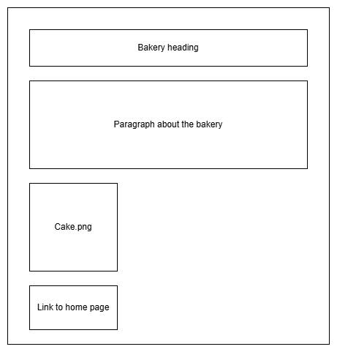

Task 7 - Security
You must identify any security concerns and design solutions for each.
Our website is saved on school computers, not on the internet, so it’s safer from cyber-attacks.
School accounts have passwords, which helps protect it.
We should also keep a backup in case something goes wrong.

Task 8 – Test plan
Design tests for your webpages to check that the text, images and links work correctly.
You should also test if your page works with the rest of the project (integration).
Page: About
Test | Description
Design | Page matches the wireframe design.
Text displays | View the webpage in browser to see the heading and paragraph.
Image displays | View the webpage in browser to see the cake image.
Link works | Click the link to check it takes you to the homepage.
Integration | Combine my webpage with my team pages to check if they work together.

Group contribution (Design)
Describe how you contributed to your team's design phase during tasks 4–8 of the project.
I planned the tests for the About page.
I also helped Tom with the home page wireframe design.

Implementation / Testing

Task 9 – Implementation
Create your webpages and insert screenshots of your code below.
Page: About.html
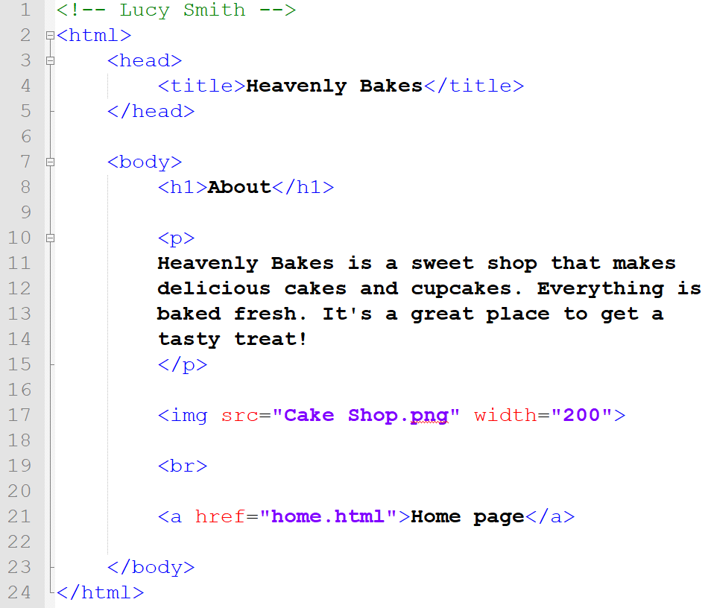

Screenshots
Insert a screenshot of your finished webpages.
Page: About.html
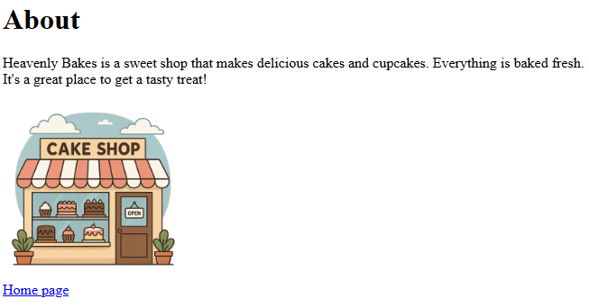

Task 10 – Deployment
It is now time to deploy the project.
Team members must join their pages together to create the finished website.
Insert a screenshot of the final project folder.
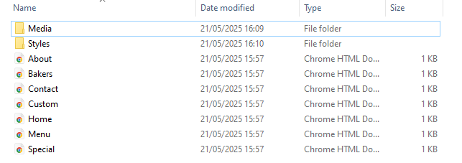

Show your finished website to your teacher and ask them to sign below.
Teacher signature: | R McHugh

Task 11 – Test your pages
Look back to your test plan (task 8) and copy it plan into the table below.
Carry out the tests and indicate a pass (✓) or fail (X).
Page: About.html
Test | Description | Pass (✓) / Fail (X) | Comment
Design | Page matches the wireframe design. | ✓
Text displays | View the webpage in browser to see the heading and paragraph. | ✓
Image displays | View the webpage in browser to see the cake image. | ✓
Link works | Click the link to check it takes you to the homepage. | ✓
Integration | Combine my webpage with my team pages to check if they work together. | X | My image worked on my computer, but when we joined all the pages together, it stopped working.  The link to my page was still working, it was just the image that broke.

Group contribution (Implementation / Testing)
Describe how you contributed to your team's implementation and testing phase during tasks 9-11 of the project.
I created the code for the About page by myself.
I used email to send my files so they could be used together.
I tested the page I made using my test plan (About page).
I also helped Tom test the home page.

Evaluation

Task 12 – Matching the project plan
Describe your team’s adherence to the project plan (task 1-3).
A) – Roles and responsibilities
Our team followed the project plan well and kept to our roles.
Each person made the web pages they were given and did their job well.
This helped us stay on track and work well as a team.

B) – Tasks and timescales
We mostly stuck to the plan, but the implementation part took longer than we expected.
Even though we ran a bit over time, we still worked well together to finish the website

C) – Resources
We planned the right resources and used them well.
Notepad++ and the school PCs helped us write and test our HTML.
Chrome and the internet were useful for research.
We used Word for our write-ups and didn’t need the printer much.
We didn’t need any extra resources, so our plan worked well.

Task 13 – Personal contribution
Describe your personal contribution to the project.
I designed and made my own webpage using HTML.
I also helped Tom with his wireframe for the home page and tested his page to make sure it worked properly.
I didn’t help with anyone else’s pages, but I made sure my own page was finished and matched the team’s design.

Task 14 – Challenges and successes
State the challenges and successes you experienced during the project.
Challenges
One challenge we had was when we tested the website and found that some images didn’t show up.
This was because we had used different folders for the images, so the code couldn’t find them.
We fixed it by moving the images into the same folder and updating the code.

Successes
A success was that we all finished our own pages, and once everything was joined together, the website links worked well.

Task 15 – Team work skills
State how you have improved your team working skills.
I have got better at working in a team because I learned how important it is to share ideas and help each other.
At the start, I mostly just worked on my own page, but then I helped Tom with his wireframe and testing.
This made me feel more confident talking and working with others.

Task 16 – Communication skills
State how you have improved your communication skills.
I have improved my communication skills by learning to talk more with my team and share ideas.
At first, I found it hard to accept help because I wanted to do things on my own. But during the project, I saw that asking for help and giving feedback made the work better.
Helping Tom with his wireframe and testing also helped me get better at explaining things clearly.

Task 17 – Collaboration skills
State how you have improved your collaboration skills.
I improved my collaboration skills by working with my whole team (Tom, Sophie, and Chris).
I worked closely with Sophie since we were at the same level, which was really helpful.
As a team, we made sure our pages matched our chosen style. This helped me get better at solving problems with others, instead of just working on my own.

