NPA Computing Technologies Project (Level 6)

EXAMPLE ANSWERS

Name
Write your name and level (4/5/6) below.
Name | Level
Tom Muir | 6

Team members
Write the names of your team members and their levels below.
Name | Level
Sophie Kenny | 4
Lucy Smith | 4
Chris Hamilton | 5


Project– Heavenly Bakes
Your team must design and build a multi-page website for the cake shop, Heavenly Bakes.
The pages must be linked together to form one complete website.
Example Pages | Description
Home.html | Welcome with a short paragraph about the bakery and a few cake images
About.html | Information about the history of Heavenly Bakes, including the story of how it started
Menu.html | A list of available cakes with short descriptions, prices, and serving sizes
Custom.html | Information on custom cake orders, like wedding cakes or themed birthday cakes, with example pictures
Bakers.html | Introduction to the bakery team with photos and short bios of each baker
Special.html | Spotlight on one special cake each month with a description and a promotional offer
Contact.html | A page with the bakery’s address, phone number, email address, a contact form (optional), and a small map image
… | …

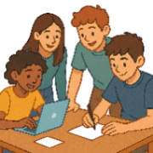
Assessment criteria
The practical requirements for each level are listed below. You must also demonstrate teamwork and your contribution to the project.
Level | Requirements | HTML | CSS
4 | One HTML page | Heading  Paragraph  Image  Link | None
5 | Two HTML pages  Internal CSS | Heading  Paragraph  Image  Link  List | Font  Font colour  Font size  Text alignment  Background colour
6 | Three HTML pages  External CSS | Heading  Paragraph  Image  Link  List  Form  Div | Font  Font colour  Font size  Text alignment  Background colour

Project plan

Task 1 - Roles and responsibilities
Each member of the team needs to pick a role and choose different pages of the website to develop.
Identify each members role and the pages they will develop.
Name: | Lucy | Sophie | Tom | Chris
Role: | Lead Research | Lead Design | Lead Coder | Lead Tester
Pages:  (Responsibilities) | About.html | Special.html | Home.html  Contact.html  Menu.html | Custom.html  Bakers.html

Task 2 - Tasks and timescales
Your team must work together to create a project plan. List the main tasks that need to be completed for the project.
Milestone | Task | Person | Start Date | End Date
Plan | Create text for the website | Team
Plan | Find / create copyright free images | Team
Plan | Tasks and timescales | Team
Plan | Resource list | Team

Design | Identify hardware requirements | Team
Design | Identify software requirements | Team
Design | Identify any potential security concerns | Team
Design | Pick design theme and colours | Sophie
Design | Wireframes - About | Lucy
Design | Wireframes - Special | Sophie
Design | Wireframes – Home, Contact & Menu | Tom
Design | Wireframes – Custom & Bakers | Chris
Design | Site navigation structure | Team
Design | Test plan - About | Lucy
Design | Test plan - Special | Sophie
Design | Test plan - Home, Contact & Menu | Tom
Design | Test plan - Custom & Bakers | Chris

Implementation | Code - About | Lucy
Implementation | Code - Special | Sophie
Implementation | Code - Home, Contact & Menu | Tom
Implementation | Code - Custom & Bakers | Chris
Implementation | Collate code files to run website | Team

Testing | Testing - About | Lucy
Testing | Testing - Special | Sophie
Testing | Testing - Home, Contact & Menu | Tom
Testing | Testing - Custom & Bakers | Chris

Evaluation | Describe how well we matched the project plan | Team
Evaluation | Describe personal contribution to the website | Chris
Evaluation | Describe challenges and success during project | Team
Evaluation | Describe the development of meta-skills | Team

Task 3 – Project resources
Write a list of all the resources that your team will need to complete the project, including:
- Hardware – Computers, printers, peripherals or other physical devices
- Software – Any software needed for the design, implementation, testing or evaluation
- Other – Subscriptions, internet access or any other materials
Resource | Type | Why is it needed?
PC | Hardware | To design, code and test the website pages using HTML and CSS.
Printer | Hardware | To print planning documents, wireframes and test plans so that they could be reviewed and checked by the team.
Web browser | Software | Google Chrome was used to run and test the website pages to make sure links, images and formatting worked correctly.
Notepad++ | Software | Used to write and edit the HTML and CSS code because it provides syntax highlighting and makes coding easier to read and debug.
Microsoft Word | Software | Used to create the project documentation, including the project plan, testing tables and evaluation tasks.
Internet connection | Other | Required for online research, accessing copyright-free images and finding coding support when solving problems.

Group contribution (Project plan)
Describe how you contributed to your team's planning phase during tasks 1–3 of the project.
During tasks 1–3 of the project, I contributed to the planning phase by helping organise the team and develop a clear project structure. I selected the role of lead coder because I was confident in writing HTML and CSS code and supporting other team members during implementation. I also helped other members choose suitable roles based on their skills and experience.
I identified the webpages I would be responsible for developing and discussed how the work should be divided fairly across the group. In addition, I contributed ideas to the project plan by helping identify the tasks, resources and timescales needed to complete the project successfully. This helped improve organisation and allowed the team to work more efficiently throughout the project.

Design

Task 4 – Hardware requirements
Describe the requirements for the hardware resources from task 3.
Resource | Type | Requirements
PC | Hardware | A desktop PC with at least 4GB RAM, a 3.5GHz processor and enough storage space on the school network account to store the HTML, CSS and image files for the website. The PC needed to be capable of running web browsers, Notepad++ and Microsoft Word efficiently at the same time.
Printer | Hardware | Printing out documentation

Task 5 – Software requirements
Describe the requirements for the hardware resources from task 3.
Resource | Type | Requirements
Web browser | Software | Google Chrome
Notepad++ | Software | Notepad++ v6.6.9
Microsoft Word | Software | Microsoft Word 2021

Design

Task 6 - Wireframes
You must create a wireframe design for each of your webpages.
Page: Home
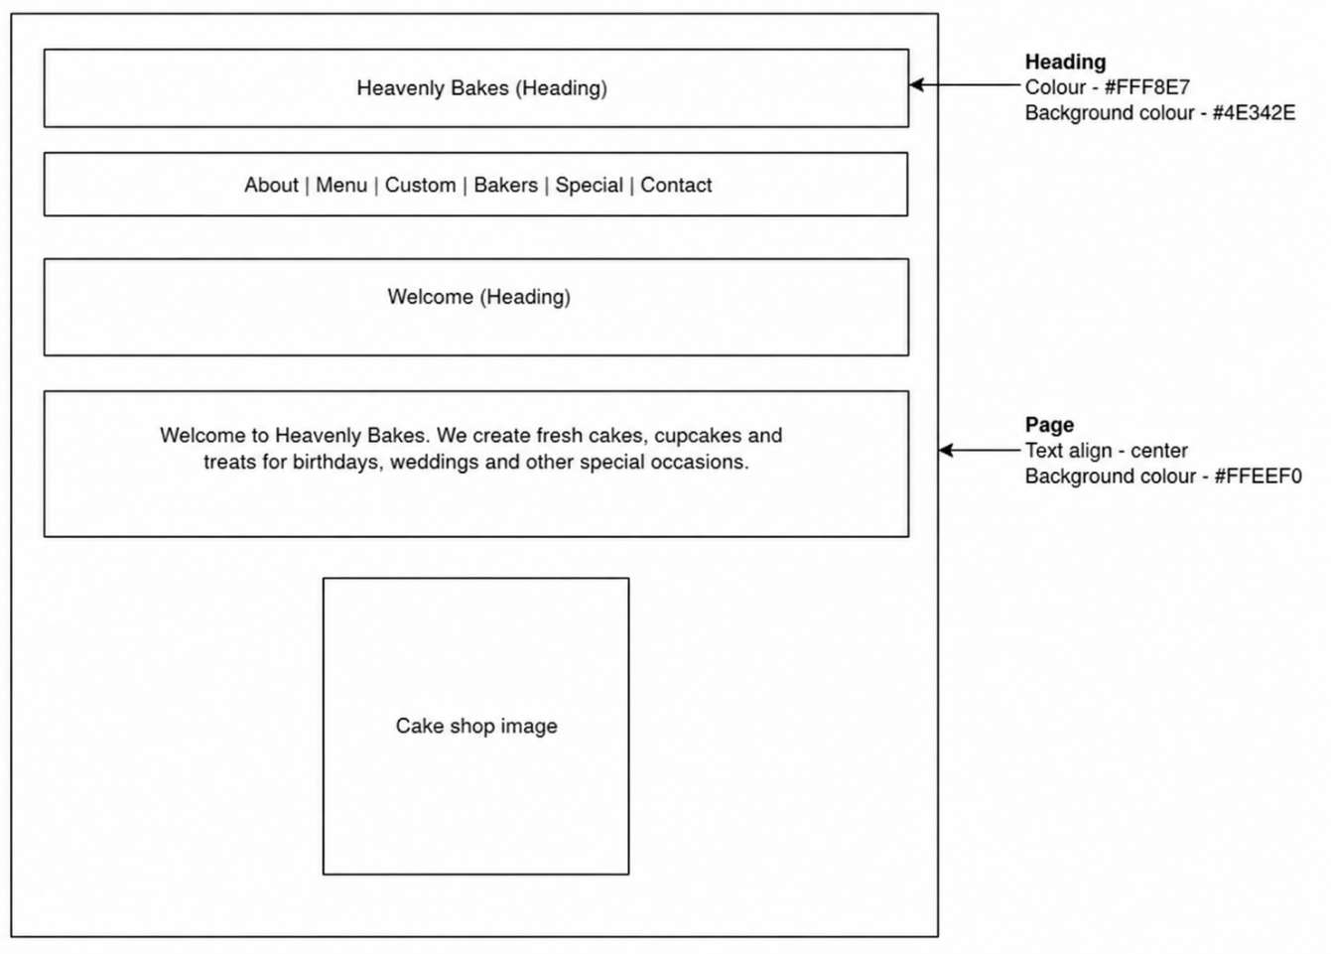

Page: Contact
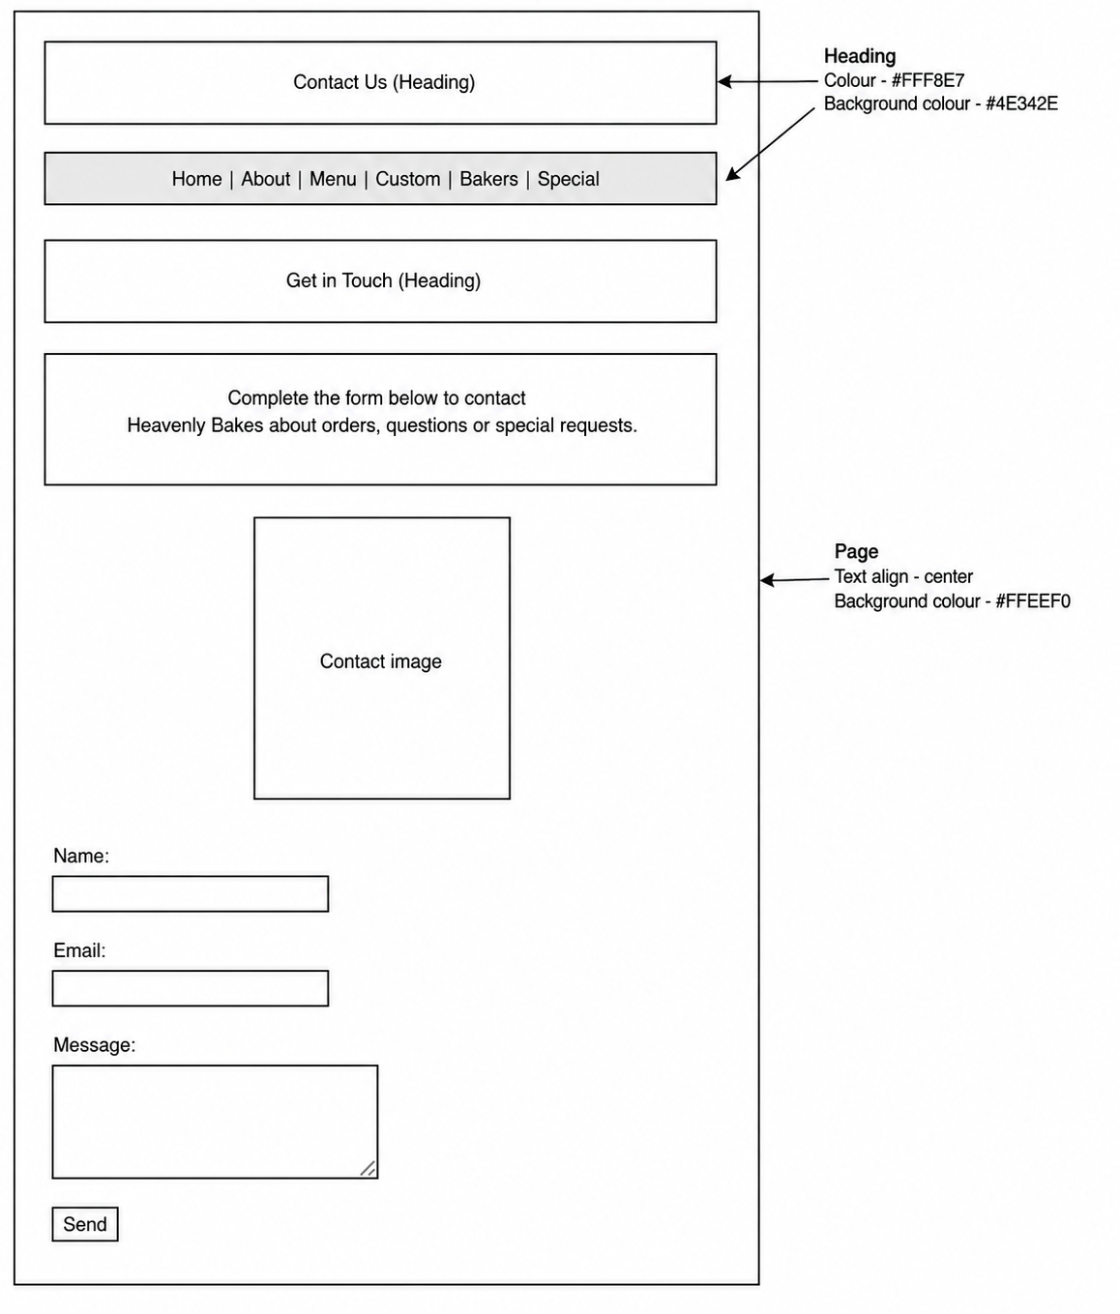

Page: Menu
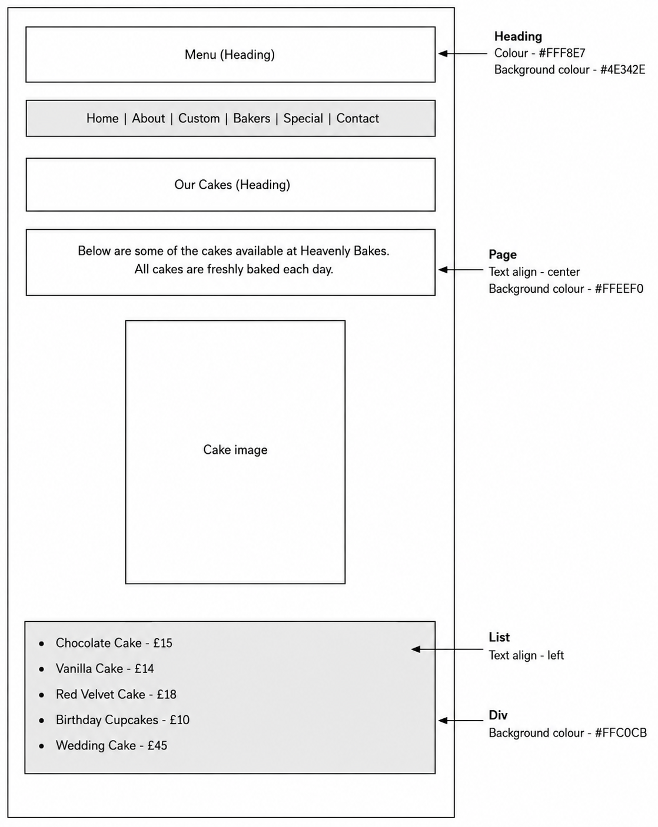

Task 7 - Security
You must identify any security concerns and design solutions for each.
Security Concern | Solution
Cyber-attacks such as DDoS attacks or hacking | The website is not hosted on a public web server, which significantly reduces the risk of external cyber-attacks such as DDoS attacks, unauthorised remote access or malicious traffic targeting the website.
Unauthorised access to project files | Each team member uses an individual school account protected by a secure username and password. This provides authentication and helps prevent unauthorised users from accessing, modifying or deleting project files.
Data loss | Team members regularly back up their HTML, CSS and image files to their GLOW cloud storage accounts. This provides redundancy and allows files to be recovered in the event of accidental deletion, file corruption or hardware failure.

Task 8 – Test plan
Design tests for your webpages to check that the text, images and links work correctly.
You should also test if your page works with the rest of the project (integration).
Page: Home
Test | Description
Design | Page matches the wireframe design. Including all styling.
Text displays | View the webpage in browser to see the heading, paragraph and list.
Image displays | View the webpage in browser to see the cakes image.
Link works | Click the link to check it takes you to the homepage.
Integration | Combine my webpage with my team pages to check if they work together.

Page: Contact
Test | Description
Design | Page matches the wireframe design. Including all styling.
Text displays | View the webpage in browser to see the headings and paragraphs.
Images display | View the webpage in browser to see the image for each baker.
Link works | Click the link to check it takes you to the homepage.
Integration | Combine my webpage with my team pages to check if they work together.

Page: Menu
Test | Description
Design | Page matches the wireframe design. Including all styling.
Text displays | View the webpage in browser to see the headings and paragraphs.
Images display | View the webpage in browser to see the image for each baker.
Link works | Click the link to check it takes you to the homepage.
Integration | Combine my webpage with my team pages to check if they work together.
Group contribution (Design)
Describe how you contributed to your team's design phase during tasks 4–8 of the project.
I completed the wireframe designs for the custom and bakers pages. This included the styling.
I helped identify some of the security concerns for the website and suggested backing up the files to GLOW.
I planned the tests for the custom and bakers pages.

Implementation

Task 9 – Implementation
Create your webpages and insert screenshots of your code below.
Page: Home.html
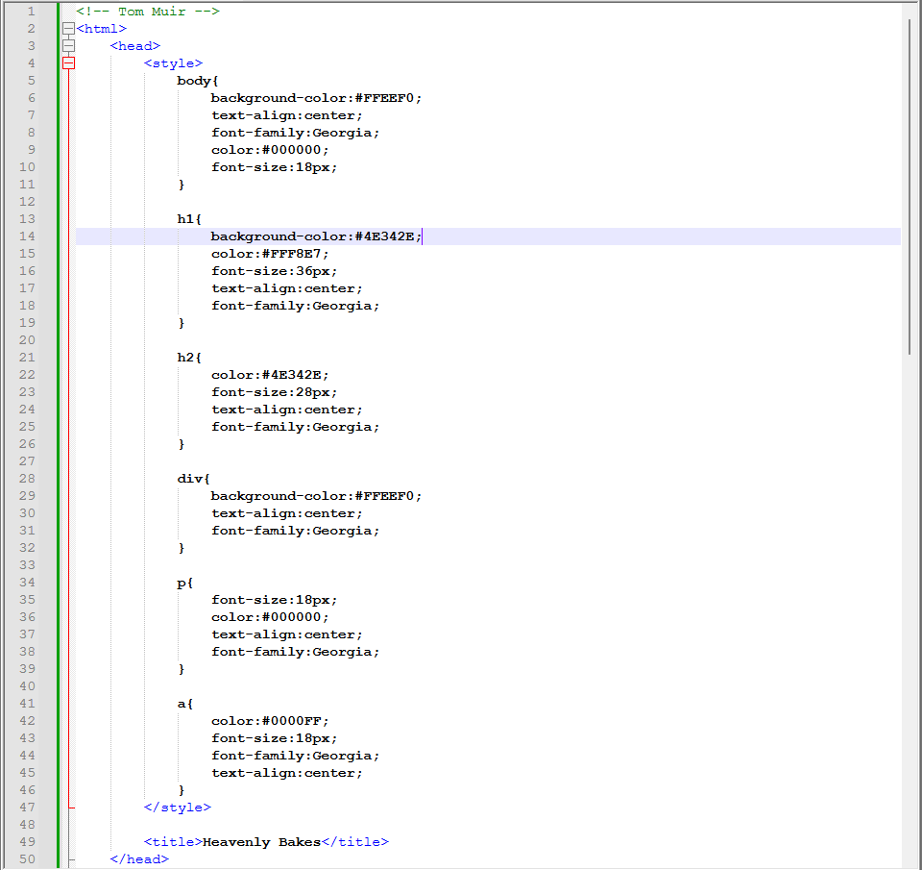
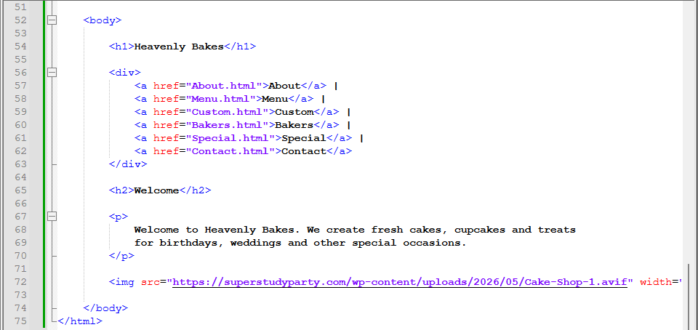

Page: Contact.html
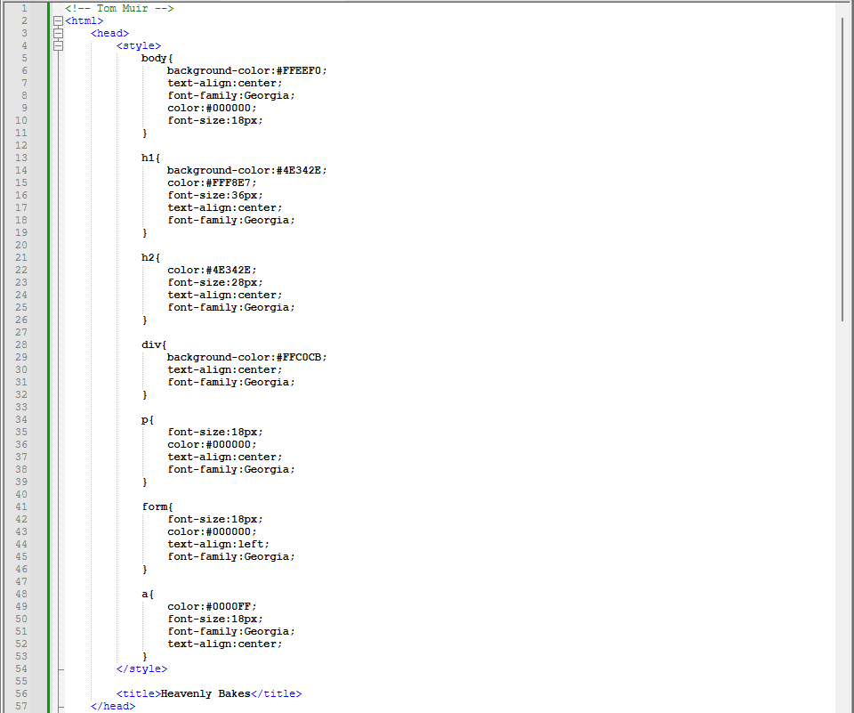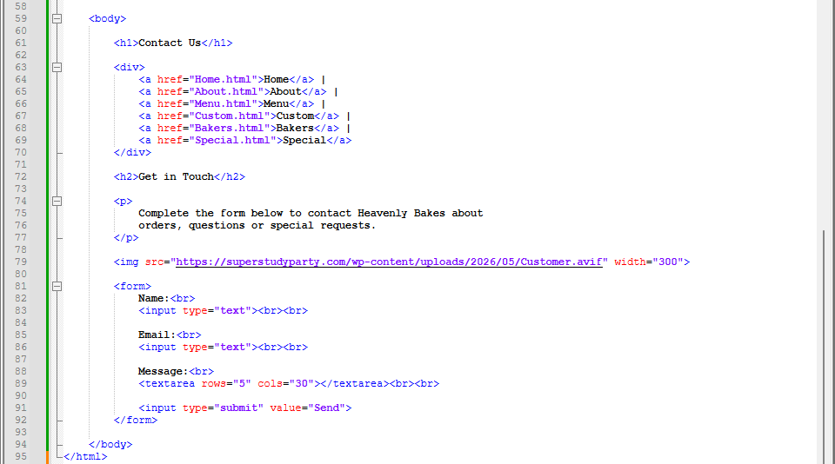

Page: Menu.html
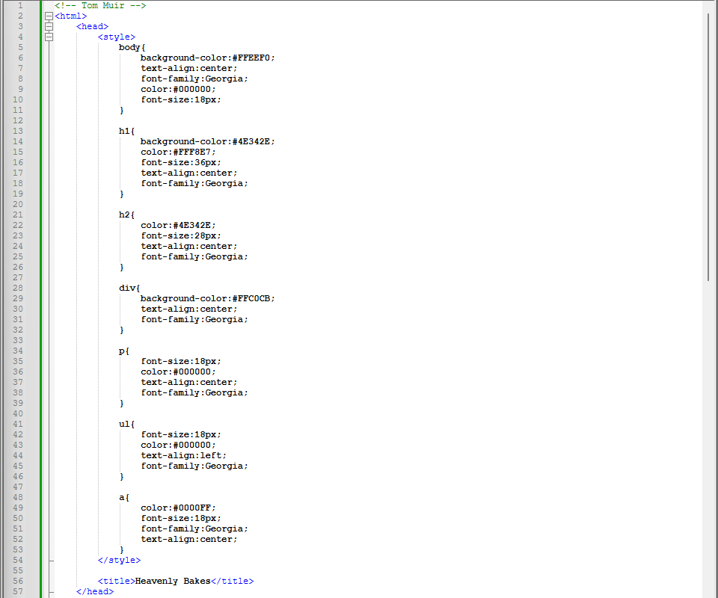
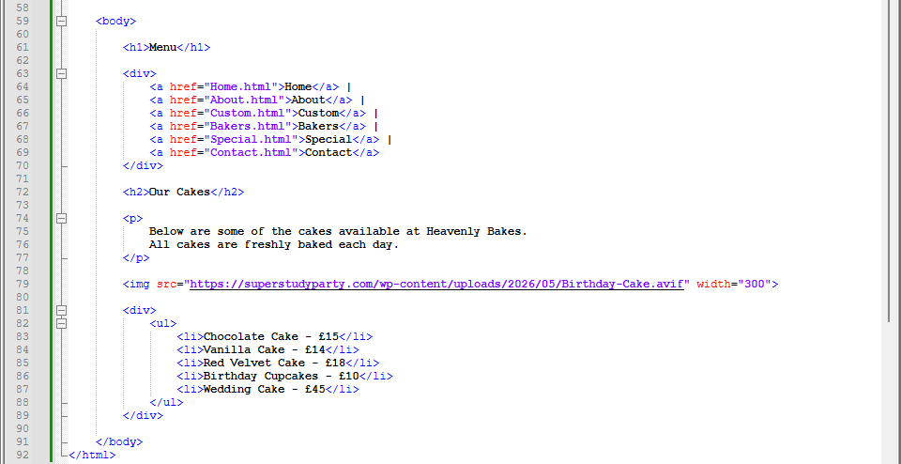

Screenshots
Insert a screenshot of your finished webpages.
Page: Home.html
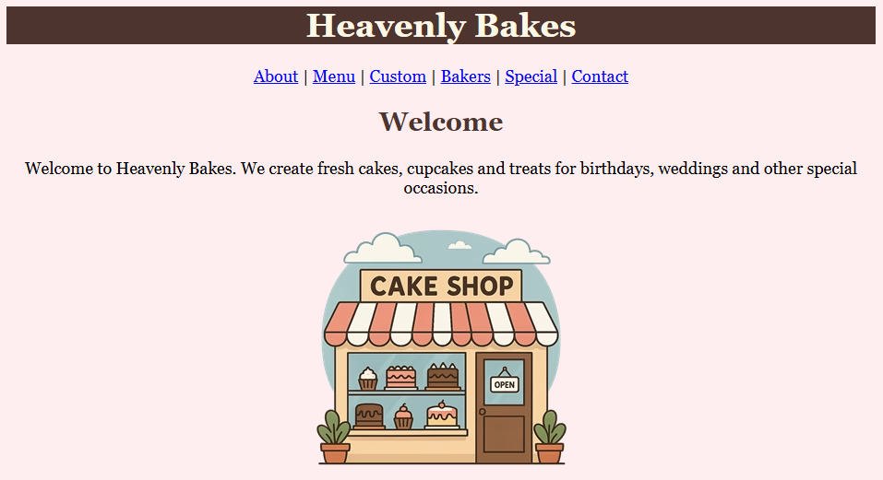

Page: Contact.html
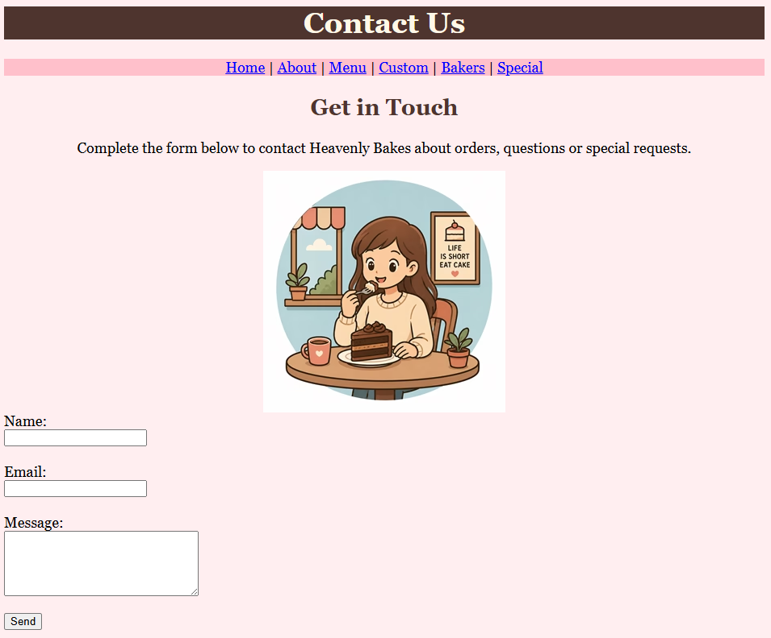

Page: Menu.html
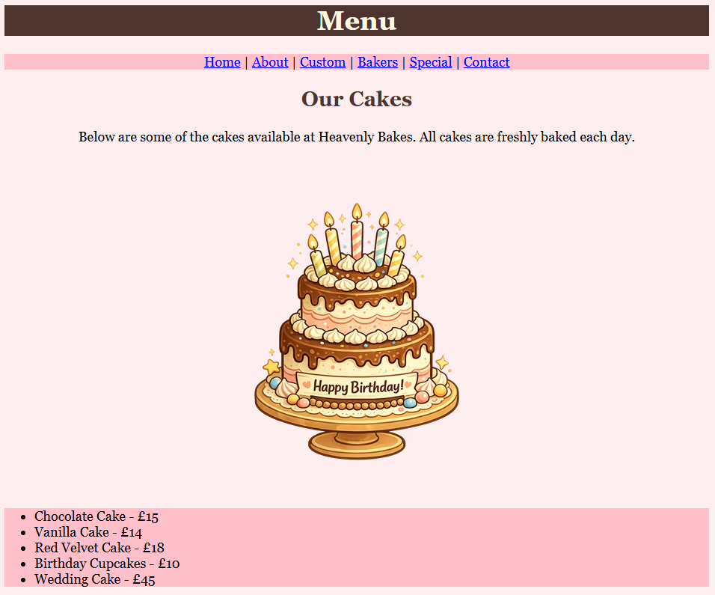

Task 10 – Deployment
It is now time to deploy the project.
Team members must join their pages together to create the finished website.
Insert a screenshot of the final project folder.
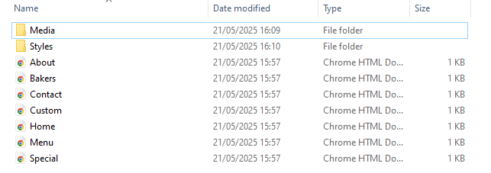

Show your finished website to your teacher and ask them to sign below.
Teacher signature: | R McHugh

Testing

Task 11 – Test your pages
Look back to your test plan (task 8) and copy it plan into the table below.
Carry out the tests and indicate a pass (✓) or fail (X).
Page: Custom.html
Test | Description | Pass (✓) / Fail (X) | Comment
Design | Page matches the wireframe design. Including all styling. | ✓
Text displays | View the webpage in browser to see the heading, paragraph and list. | ✓
Image displays | View the webpage in browser to see the cakes image. | ✓
Link works | Click the link to check it takes you to the homepage. | ✓
Integration | Combine my webpage with my team pages to check if they work together. | ✓

Page: Bakers.html
Test | Description | Pass (✓) / Fail (X) | Comment
Design | Page matches the wireframe design. Including all styling. | ✓
Text displays | View the webpage in browser to see the headings and paragraphs. | ✓
Images display | View the webpage in browser to see the image for each baker. | ✓
Link works | Click the link to check it takes you to the homepage. | ✓
Integration | Combine my webpage with my team pages to check if they work together. | ✓

Group contribution (Implementation / Testing)
Describe how you contributed to your team's implementation and testing phase during tasks 9-11 of the project.
I wrote the code for the custom and bakers pages.
I copied my files to my other team mates using a USB flash drive.
I used my test plans to test both my pages and had no errors.
As my role was lead tester I helped my team mates with their tests and double checked a few to make sure they worked correctly.
I helped pick the background colour to use in the groups CSS.
I also helped other team members with small syntax errors.

Evaluation

Task 12 – Matching the project plan
Describe your team’s adherence to the project plan (task 1-3).
A) – Roles and responsibilities
Each member of our team done a good job with their role.
Even though we had lead roles we still helped each other.
Everyone managed to complete all the pages they were responsible for.

B) – Tasks and timescales
We managed to stick to the timescales for the plan, design, testing and evaluation.
The implementation took longer than expected but we managed to get back on track by working together and helping each other with the code.

C) – Resources
All of our resources were planned appropriately.
The school computers were ideal for creating the website as we were familiar with them and knew that they could handle HTML coding.
The software all worked as expected with Notepad++ and Chrome meeting our requirements for web development.
Other resources like Word, Printer and an internet connection allowed us to complete the research and written parts of our project.

Task 13 – Personal contribution
Describe your personal contribution to the project.
I designed, implemented and tested the two web pages I was responsible for.
The pages integrated with the website well without the need for any code fixes.
I also helped my team mates with small things such as suggesting a test or fixing a syntax error.
I did well in my role as lead tester as I looked over everyone’s webpages and double checked a few tests.

Task 14 – Challenges and successes
State the challenges and successes you experienced during the project.
Challenges
Lucy’s images didn’t work when we integrated the webpages together but I realised that it was because she had used a different file path from everyone else. This was easily fixed.
We didn’t have a plan for how to join our pages together so we ended up using different methods (I used a USB flash drive and Lucy used email).

Successes
The big success of this project was that the website worked when we joined our pages together with minimal fixes.
We also worked well as a team and were comfortable collaborating once we started.

Task 15 – Team work skills
State how you have improved your team working skills.
I am more confident in asking for help from people as there were a few times I wasn’t sure how to complete a task and got help from my team.
I also feel more comfortable offering help or pitching my ideas during a discussion, like when we were talking about what colours we should use for the website or what tests we would need.

Task 16 – Communication skills
State how you have improved your communication skills.
I have improved my communication skills by learning to wait for my opportunity to talk rather than talk over others.
I used to get quite frustrated waiting for my turn to speak but I definitely feel more comfortable letting others talk.

Task 17 – Collaboration skills
State how you have improved your collaboration skills.
I improved my collaboration skills by working as a team instead on individually.
I tried to help everyone in the team when they were stuck.
I also made sure to give everyone a chance to speak during discussions.
I think the fact that we had regular group discussion to talk about our progress helped build a strong feeling of collaboration.

