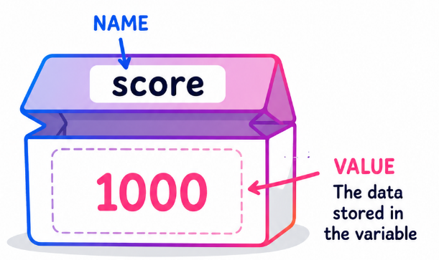
Variables - Answers
Computing Foundations (Level 4)

Targets
 | - Identify variables used in a program.

Task 1
- What name is given to the named location of stored data in a program?
- Data Type
- Loop
- Syntax
- Variable

- Identify the variable in the following code.
if exam_score > 70:
print(“You got an A!”)

- print
- exam_score
- if
- You got an A!

- Identify the variable in the following code.
fruit = “Apple”:
print(“My favourite fruit:”, fruit)

- “Apple”
- print
- Apple
- fruit

Task 2
Complete the following statement using the word bank below.
Variables are named locations of stored data in a program which can be changed using code. A program can have multiple variables so it is important to give variables simple and meaningful names.
multiple | changed | locations | simple

Task 3
Identify the variables and data types for the following program specifications.
Program | Variables | Data Types
A pet shop program stores:  - The name of a pet  - The age of the pet | Pet_Name | String
 | pet_age | Integer

Program | Variables | Data Types
A cinema ticket program stores:  - The film name  - The number of tickets sold  - The price of each ticket | film_name | String
 | tickets_sold | Integer
 | ticket_price | Float/Real

Program | Variables | Data Types
A pizza ordering program stores:  - the customer’s name  - the number of toppings on a pizza  - the cost of the order  - the delivery address | customer_name | String
 | number_toppings | Integer
 | Total_cost | Float/Real
 | delivery_address | String

Study
Continue your study at www.superstudyparty.com
- NPA Computing Technologies (Level 4)  - Computing Foundations  - Variables | 

