
The Internet - Answers
Computing Foundations (Level 4)

Targets
 | - Describe the purpose of the internet.  - Describe the purpose of routers and cables.  - Describe the purpose of an Internet Service Provider.

Task 1
- What is the main purpose of the internet?
- Connecting devices locally and allowing the playing of games online.
- Connecting devices to a server to stream different types of media.
- Connecting devices worldwide and allow the sharing of data and communication.
- Connecting devices mobile devices to a network so they can use the internet.

- What hardware is required to connect to the internet?
- Switches
- Routers and Cables
- Mobile Devices
- WiFi Range Extender

- What is the main role of an internet service provider?
- Providing internet access to homes and businesses.
- Managing Usernames and Password for users.
- Protecting networks using firewalls and encryption.
- Verifying user identity through login systems.

Task 2
Complete the following statement using the word bank below.
The internet connects devices worldwide. People can access the internet by using an Internet Service Provider which is also called an ISP. Data travels along cables to get to the user and devices can connect to a router to use the internet.
ISP | router | cables | worldwide

Task 3
Complete each statement and place them in the correct boxes to explain how the internet works.
- The Internet Service Provider provides internet access.
- A router sends and receives data.
- Devices connect to the router using cables.
- Devices can access the internet!.
- Cables connect the ISP to homes.
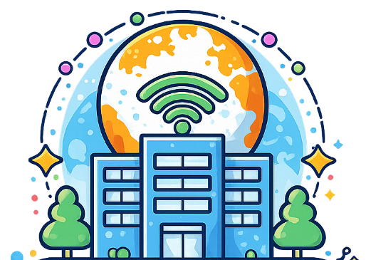
The Internet Service Provider provides internet access.

Cables connect the ISP to homes.


A router sends and receives data.


Devices connect to the router using cables.

Devices can access the internet!

Task 4
Complete the wordsearch below that contains terms related to the internet.


network | internet | service | provider
router | cables | data | sharing

Study
Continue your study at www.superstudyparty.com
- NPA Computing Technologies (Level 4)  - Computing Foundations  - The Internet | 

