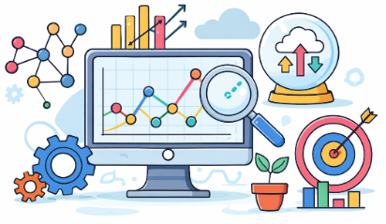
Data in Society - Answers
Computing Foundations (Level 4)

Targets
 | - State the role of data in society

Task 1
- What is Data?
- Raw facts and figures that can be processed into information.
- A type of computer used to store programs.
- Instructions that tell a computer what to do.
- A finished report created from analysed information.

- What is a key role of data in society?
- Make search engines faster
- Allows people to work better independently
- Supports decision-making
- Completes jobs for humans that are repetitive

- What is Big Data?
- Extremely large datasets that are used to find patterns.
- Data like images that takes up a lot of storage.
- A type of computer used to store small amounts of personal files.
- Sorting files and folders in a complicated way.

- In our society, what is a common use of Big Data?
- Installing software updates on a device
- Providing Network Security
- Personalised Advertisements
- Making encryption more secure

Task 2
Complete the following statements using the word banks below.
- Data is made up of facts and figures that can be collected and analysed. We can use data to find patterns that can help us make predictions about what might happen in the future. It can also be used to solve problems.
patterns | problems | figures | predictions

- Big Data helps solve real-world problems in society. Big Data uses very large datasets of information. Having more data in a dataset helps identify complex patterns which can solve more complicated problems.
complex | problems | society | datasets

Task 3
Match the uses of data to the correct areas of society.
Transport |  | Tracks patient records and predicts disease outbreaks
Social Media |  | Helps schools understand progress and plan support
Shopping |  | Used to plan bus routes reduce traffic jams
Education |  | Shows what products are popular and personalises advertisements
Healthcare |  | Suggest content based on what users like and share

Take a Test
Continue your study at www.superstudyparty.com
- NPA Computing Technologies (Level 4)  - Computing Foundations  - Data in Society | 

