Data Advantages and Challenges
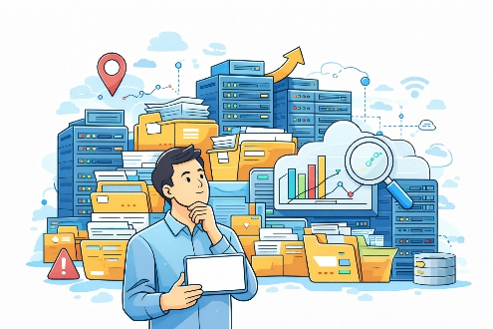
Computing Foundations (Level 4)

Targets
 | - State the advantages of using data  - State the challenges of using data

Task 1
- Why should businesses use data analytics?
- To make more money
- Requires less staff
- Improved decision making
- To make their business better

- What is an advantage of using Big Data?
- Better understanding
- No training required
- Less storage required
- Save money

- What is the main challenge that big data faces?
- Slows down the internet
- Processing data is slow
- More power is required
- Bigger storage requirements

Task 2
Complete the following statement using the word bank below.
One of the _____________ of using Big Data is that it improves our ______________ of information which helps people and businesses make better ___________. However, a challenge of Big Data is that it requires a lot of ____________ to store all the information.
understanding | decisions | advantages | storage

Task 3
Identify if each statement about Data as an advantage or a challenge.
Statement | Advantage or Challenge?
Data improves decision making.
Data can help predict disease outbreaks.
It can be difficult to manage big data sets.
Data trends can be used to provide recommendations.
Big data can require large amounts of storage.
Data can come from many different sources.
Data can come in many different formats.
Data can be used to identify patterns and trends.

Task 4
State one advantage and one challenge of using data.
Advantage
Challenge

Take a Test
Continue your study at www.superstudyparty.com
- NPA Computing Technologies (Level 4)  - Computing Foundations  - Data Advantages and Challenges | 

