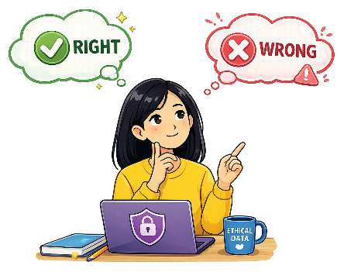
Data Ethics
Computing Foundations (Level 4)

Targets
 | - State ethical considerations when sharing data

Task 1
- What is Data Ethics?
- Techniques for analysing data to find patterns and make predictions.
- Rules for storing data safely to prevent it being lost or damaged.
- Methods for organising data so it can be searched and sorted easily.
- Using data responsibly, fairly and respecting people’s privacy.

- Why is data privacy important?
- It decreases your chance of being hacked.
- It decreases storage requirements.
- It protects personal information.
- It ensures your data is backed up.

- When working with data, what is one ethical consideration?
- Using the data quickly
- Ensuring the data is backed up
- Ensuring data privacy
- The download speed of the data

- What ethical considerations should be taken when sharing data?
- The size of the data
- The user’s privacy
- The value of the data
- The speed of the transfer

Task 2
Complete the following statement using the word bank below.
Data privacy is aims to protect people’s _______________ when handling their data. _______________ means removing personal details from data. Data sharing must follow the ____________. You should always ask for _______________ before collecting data.
law | consent | privacy | anonymisation

Task 3
Match each data ethics terms to their correct descriptions.
Privacy |  | Removing personal details from data
Anonymisation |  | Asking permission to use data
Consent |  | Protecting personal information
Fair Use |  | Using data honestly and not causing harm

Task 4
Complete the following sentences about data ethics and privacy.
- Data ethics is important because _________________________________________.
- Companies should aim to protect data because _________________________________.
- When talking about data ethics, one thing to consider is _________________________.
- Failure to protect a person’s data could result in ________________________________.

Take a Test
Continue your study at www.superstudyparty.com
- NPA Computing Technologies (Level 4)  - Computing Foundations  - Data Ethics | 

