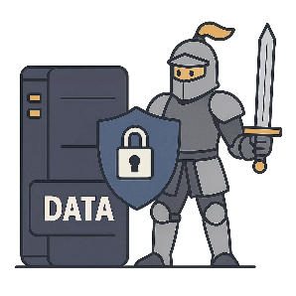
Data Security - Answers
Computing Foundations (Level 4)

Targets
 | - State two ways to keep data secure.

Task 1
- Which of the following would help keep data secure?
- Using anonymous emails
- Using strong passwords
- Using strong usernames
- Using back up software

- Which of the following would help keep data secure?
- Compression
- Encryption
- Obfuscation
- Encoding
- Which of the following is the strongest password?
- Super_study_party1!
- superstudyparty
- 12345678910
- Sup3r5tudyP@rty1!

Task 2
Fill in the blanks using the word bank below.
There are two ways in which data can be kept secure. Accounts and information can be protected by using strong passwords. Information can be made unreadable to anyone without permission by using encryption.
passwords | encryption | secure | data

Task 3
Complete the following text exchange. You should provide four ways to ensure that a password is regarded as strong.

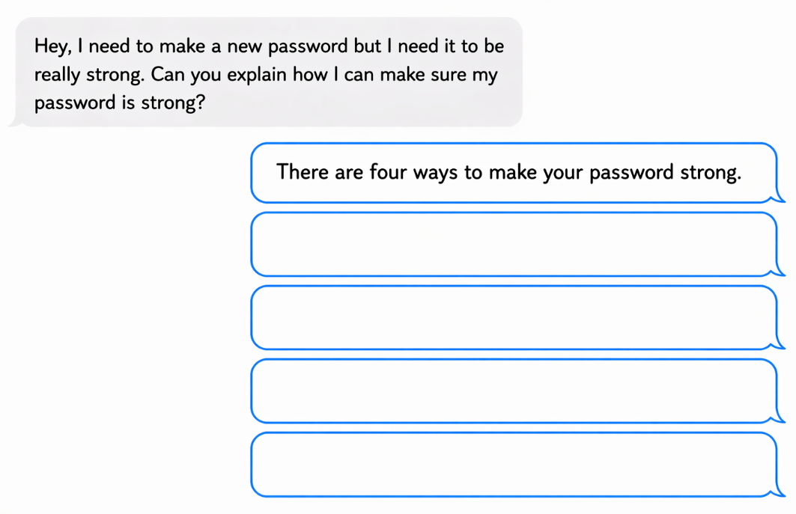
Make sure your password isn’t guessable or obvious.
Use a mix of letters, numbers and symbols.
Use a mix of lowercase and uppercase characters.
Make your password at least 8 characters long.

Task 4
Decrypt the following messages. Find each encrypted letter to find the actual letter and reveal a secret message.
Actual | A | B | C | D | E | F | G | H | I | J | K | L | M
Encrypted | D | E | F | G | H | I | J | K | L | M | N | O | P
Actual | N | O | P | Q | R | S | T | U | V | W | X | Y | Z
Encrypted | Q | R | S | T | U | V | W | X | Y | Z | A | B | C

Encrypted Message | Actual Message
L ORYH SLCCD | I LOVE PIZZA
VWXGBLQJ LV JRRG | STUDYING IS GOOD
HQFUBSWLRQ LV IXQ | ENCRYPTION IS FUN

Study
Continue your study at www.superstudyparty.com
- NPA Computing Technologies (Level 4)  - Computing Foundations  - Data Security | 

