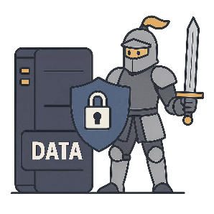
Data Security
Computing Foundations (Level 4)

Targets
 | - State two ways to keep data secure.

Task 1
- Which of the following would help keep data secure?
- Using anonymous emails
- Using strong passwords
- Using strong usernames
- Using back up software

- Which of the following would help keep data secure?
- Compression
- Encryption
- Obfuscation
- Encoding
- Which of the following is the strongest password?
- Super_study_party1!
- superstudyparty
- 12345678910
- Sup3r5tudyP@rty1!

Task 2
Fill in the blanks using the word bank below.
There are two ways in which _______________ can be kept _______________. Accounts and information can be protected by using strong _______________. Information can be made unreadable to anyone without permission by using _______________.
passwords | encryption | secure | data

Task 3
Complete the following text exchange. You should provide four ways to ensure that a password is regarded as strong.

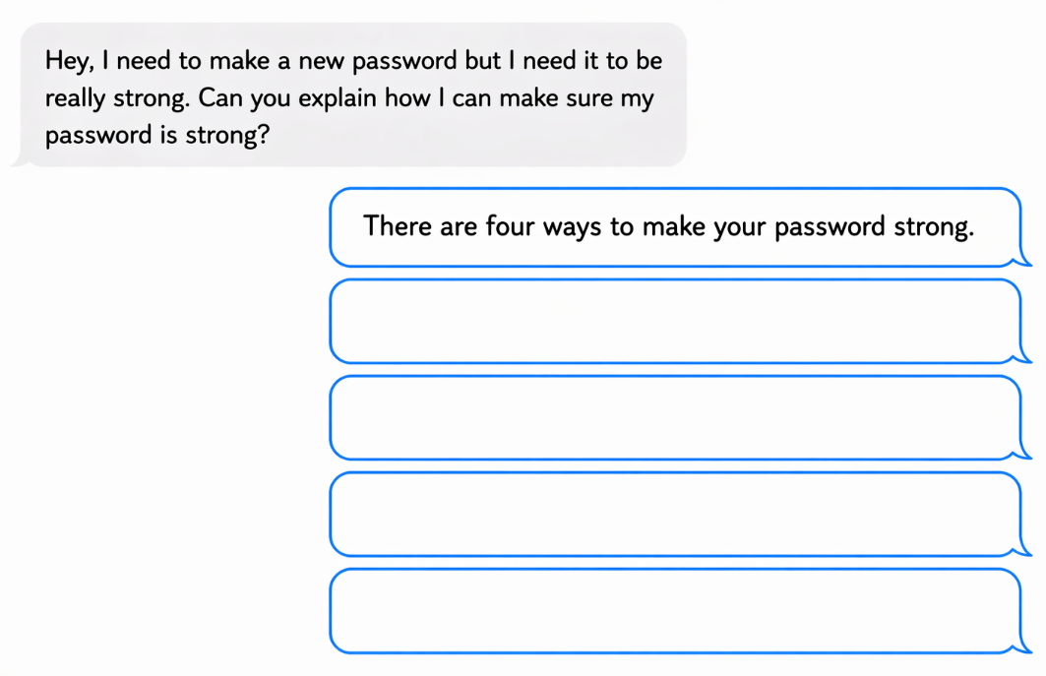

Task 4
Decrypt the following messages. Find each encrypted letter to find the actual letter and reveal a secret message.
Actual | A | B | C | D | E | F | G | H | I | J | K | L | M
Encrypted | D | E | F | G | H | I | J | K | L | M | N | O | P
Actual | N | O | P | Q | R | S | T | U | V | W | X | Y | Z
Encrypted | Q | R | S | T | U | V | W | X | Y | Z | A | B | C

Encrypted Message | Actual Message
L ORYH SLCCD
VWXGBLQJ LV JRRG
HQFUBSWLRQ LV IXQ

Study
Continue your study at www.superstudyparty.com
- NPA Computing Technologies (Level 4)  - Computing Foundations  - Data Security | 

