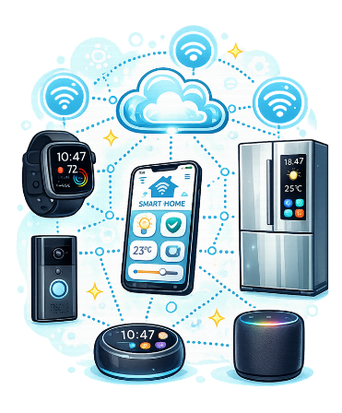
Internet of Things (IoT)
Computing Foundations (Level 4)

Targets
 | - Describe what IoT is.  - State the impact of IoT on our lives.  - State an advantage of using IoT.

Task 1
- Which best describes what Internet of Things is?
- Connects some devices together to share information.
- Connects everyday devices together using the internet.
- Connects the internet to devices that don’t have internet access.
- Connects to the internet to update devices.

- How can IoT have a social impact?
- By letting people use social media.
- By protecting people’s data from hackers.
- By ensuring devices are always on the internet.
- By making lives easier, safer and more efficient.

- What is the main advantage of using IoT?
- IoT devices can be connected together.
- IoT devices are cheaper and therefore more accessible.
- IoT networks are hacker proof.
- IoT networks don’t require any security.

Task 2
Complete the following statement using the word bank below.
Internet of Things (IoT) creates a network of everyday physical devices connected to the internet. Each device shares data and performs tasks. IoT aims to make lives easier, safer and more efficient by using data.
internet | data | easier | network

Task 3
Below is a list of everyday devices and objects. For each device, provide an example of how it could be made better by making it part of the Internet of Things.
Device | How it could be made better?
Doorbell | Sends video to your phone when someone presses the button.
Watch | Example: Can control outdoor lights to improve security.
Speaker | Example: Can give you traffic updates before you leave house.
Fridge | Example: Can tell you when food is out of date.
Heating System | Example: Can manage itself to save money / energy.
Security Camera | Example: Can send an alert when it identifies a stranger.
Pet Collar | Example: Can monitor how often they approach food bowls.
Car | Example: Sends reminders to charge if the weather is good.
TV | Example: Can remind you to do things (work, drink water).

Task 4
In your own words, answer the following questions giving an example for each one.
Describe what is meant by increase device connectivity in the Internet of Things.
More devices can connect together making the Internet of Things better.

Describe one societal benefit of the Internet of Things.
Societal benefits include:
Making people’s lives easier, making people’s lives safer, making people’s lives more efficient.

Study
Continue your study at www.superstudyparty.com
- NPA Computing Technologies (Level 4)  - Computing Foundations  - Internet of Things (IoT) | 

