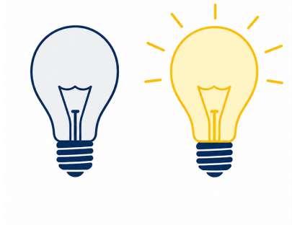
4-Bit Binary
Computing Foundations (Level 4)

Targets
 | - Explain what binary is  - Convert binary to denary  - Convert denary to binary

Task 1
- What numbers is binary made up of?
- 1 to 10
- All numbers.
- 1’s and 0’s
- Only odd numbers

- What type of language is binary regarded as?
- Markup Language
- Machine Language
- Scripting Language
- High Level Programming Language

- What is the smallest number that can be represented with 4-bit binary?
- 1
- 0
- 15
- 16

D) What is the largest number that can be represented with 4-bit binary?
- 16
- 4
- 1
- 15

Task 2
Convert the following numbers from Binary to Denary and answer in the below box.
  8 | 4 | 2 | 1
  1 | 0 | 1 | 0
  8 | 4 | 2 | 1
  1 | 1 | 1 | 1
  8 | 4 | 2 | 1
  0 | 1 | 1 | 0

  8 | 4 | 2 | 1
  1 | 0 | 1 | 1
  8 | 4 | 2 | 1
  0 | 0 | 1 | 1
  8 | 4 | 2 | 1
  0 | 1 | 1 | 1

Task 3
Complete the following numbers from Denary to Binary.
8 | 12 | 9
  8 | 4 | 2 | 1
  8 | 4 | 2 | 1
  8 | 4 | 2 | 1

5 | 14 | 2
  8 | 4 | 2 | 1
  8 | 4 | 2 | 1
  8 | 4 | 2 | 1

Take a Test
- NPA Computing Technologies (Level 4)  - Computing Foundations  - 4-Bit Binary | 

