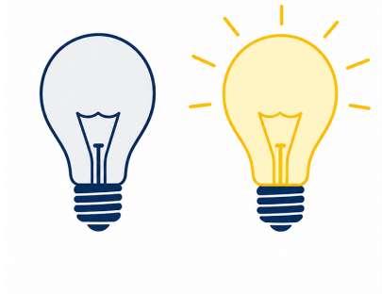
Storing Text (ASCII)
Computing Foundations (Level 4)

Targets
 | - Explain the purpose of ASCII  - Describe how binary uses ASCII to display characters

Task 1
- What does ASCII stand for?
- American Standard Code for Interchanging Information
- American Standard Code for Itemised Information
- American Simplified Code for Information Interchange
- American Standard Code for Information Interchange

- What does ASCII convert binary into?
- Characters we can use and understand
- Decimal numbers
- The alphabet
- Instructions for the CPU

- Which statement best explains why computers use ASCII?
- Computers use machine language which is written in ASCII.
- Computers use ASCII to increase the amount of memory available.
- Computers use 1’s and 0’s, but people read letters and numbers.
- Computers use ASCII to make programs run faster.

Task 2
Complete the following statement using the word bank below.
ASCII converts _______________ into letters, numbers, and symbols that people can read. Computers store information using __________. Each character in ASCII has a unique ____________. ASCII helps people understand _______________.
1’s and 0’s | characters | binary | code

Task 3
Complete the below diagram by explaining each stage of the ASCII conversion.

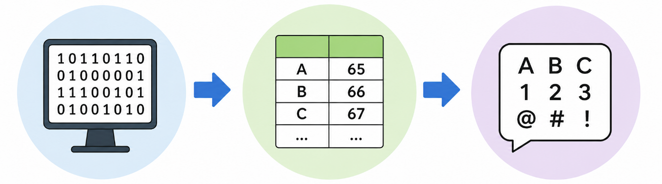

Task 4
Convert the following messages from ASCII using the conversion table.
A | B | C | D | E | F | G | H | I | J | K | L | M
65 | 66 | 67 | 68 | 69 | 70 | 71 | 72 | 73 | 74 | 75 | 76 | 77
N | O | P | Q | R | S | T | U | V | W | X | Y | Z
78 | 79 | 80 | 81 | 82 | 83 | 84 | 85 | 86 | 87 | 88 | 89 | 90

ASCII | Message
72 69 76 76 79
83 84 85 68 89
80 89 84 72 79 78
66 73 78 65 82 89
84 69 67 72 78 79 76 79 71 89

Take a Test
- NPA Computing Technologies (Level 4)  - Computing Foundations  - Storing Text (ASCII) | 

