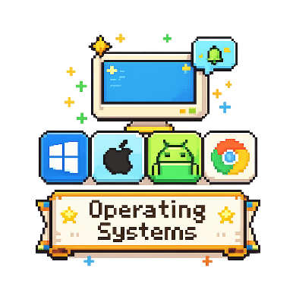
Operating Systems
Computing Foundations (Level 4)

Targets
 | - State the roles of operating systems  - Describe how an operating system manages hardware and resources

Task 1
- What is the role of an operating system?
- Displays images and videos on a monitor.
- Stores files and folders permanently.
- Manages the computer’s hardware and runs applications.
- Connects the computer to the internet.

- Why is an operating system important?
- It lets users interact with hardware and software.
- It increases the physical size of the computer.
- It stores electricity for the computer.
- It replaces the computer’s processor.

- Which of the following is NOT an operating system?
- Windows
- Android
- ChromeOS
- PowerPoint

- What is the main purpose of an operating system?
- To manage a computer’s hardware and resources.
- To connect the computer to the internet.
- To store files permanently on a hard drive.
- To display images on the monitor.

Task 2
Complete the following word search looking for words relating to operating systems.


Windows  MacOS | ChromeOs  Linux | iOS  Android

Study
Continue your study at www.superstudyparty.com
- NPA Computing Technologies (Level 4)  - Computing Foundations  - Operating Systems | 

